- Download and install Power BI Desktop on your computer, then open the application and take a screenshot of the blank report interface.
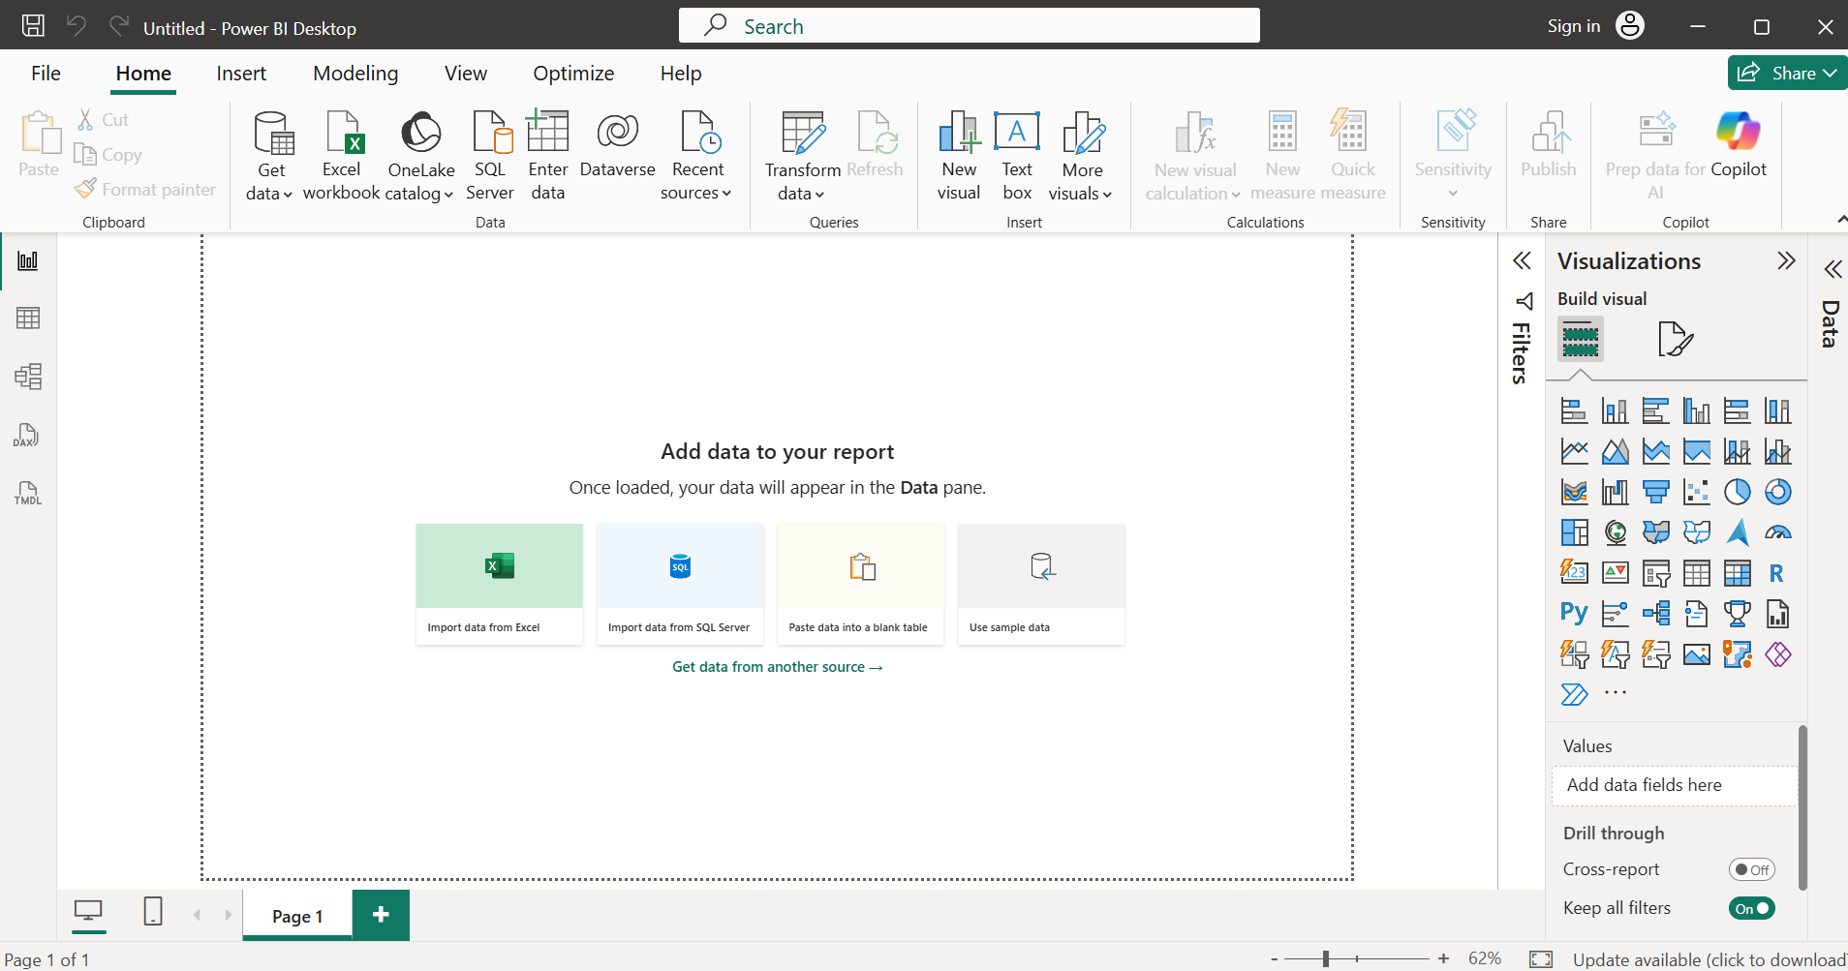

- Explore the Power BI Desktop interface and identify the following components: Report View, Data View, Model View, Fields Pane, Visualizations Pane, and Filters Pane. Write a short description (1-2 lines) for each component.
Component | Description
Report View | The main workspace for creating and arranging charts, tables, cards, and other visuals on report pages. M Microsoft Learn
Data View | Lets you inspect the actual rows and columns of data after they have been loaded into the Power BI model. M Microsoft Learn
Model View | Shows tables, columns, and relationships between tables, making it useful for understanding and managing the data model. M Microsoft Learn
Fields/Data Pane | Displays the tables and fields available in the data model. Fields can be dragged onto visuals to build reports. M Microsoft Learn
Visualizations Pane | Used to select visual types and configure their fields and formatting—for example, choosing a table, bar chart, or pie chart. M Microsoft Learn +1
Filters Pane | Used to apply filters at the visual, page, report, or drillthrough level so that users can focus on particular data. M Microsoft Learn

- Create a new blank report in Power BI Desktop and add a table visual using the Visualizations Pane. Rename the report page to 'My First Dashboard'.

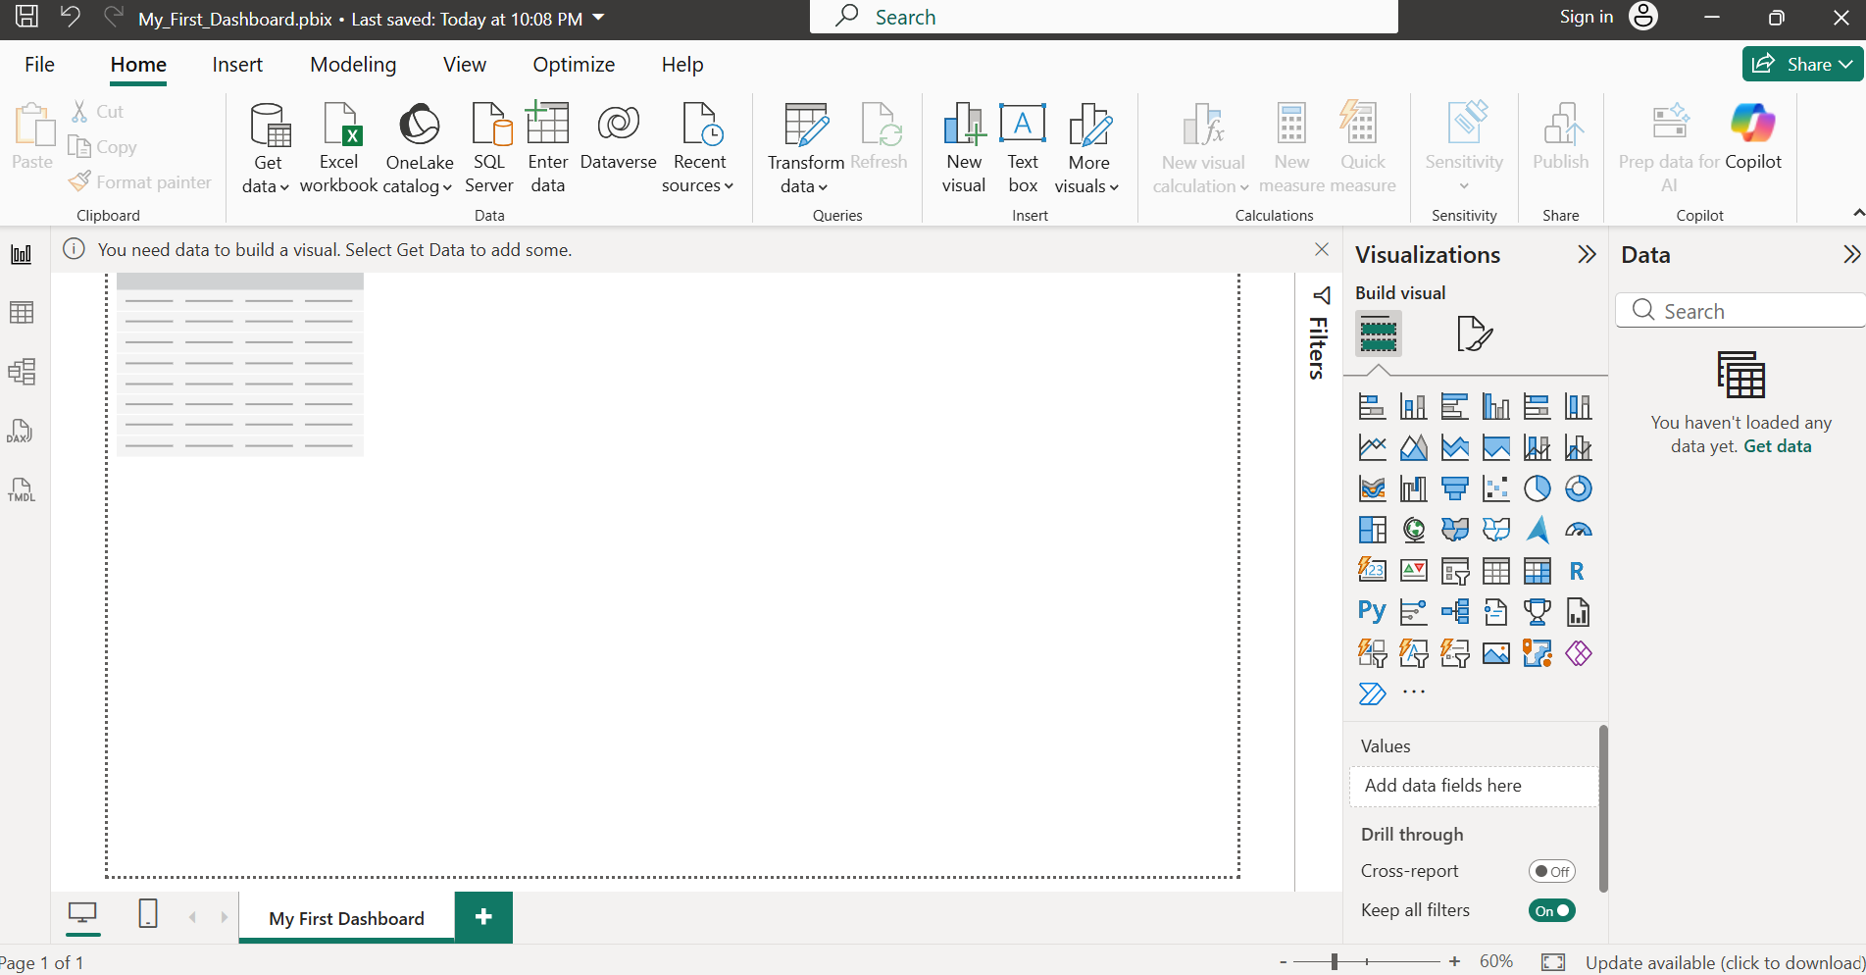

- List 3 key differences between Excel Dashboards and Power BI Dashboards, focusing on features or workflows you noticed while exploring Power BI Desktop.

Feature | Excel Dashboard | Power BI Dashboard
Data modeling | Often relies on worksheets, formulas, PivotTables, and Power Query. | Has a dedicated data-modeling environment with relationships and DAX.
Visualizations | Provides charts, PivotCharts, slicers, and other Excel objects. | Provides a broader interactive visualization environment with many built-in and custom visuals. M Microsoft Learn
Interactivity & filtering | Slicers and PivotTable controls are commonly used. | Visuals can interact through cross-filtering/cross-highlighting, with visual-, page-, and report-level filters. M Microsoft Learn +1

